**Course Project Report On**

**Patient Monitoring System using proteus**

Group Members:

45.Sudharani Hattalli.

46.Neha Jadhav.

GitHub link:

[NehaJadhav15/Patient-Monitoring-System (github.com)](https://github.com/NehaJadhav15/Patient-Monitoring-System)

<https://github.com/SudharaniSHattalli/IOT_Based_Patient_Monitoring_System>

YouTube link:

<https://youtu.be/-d5SSgmVjhI>

**Introduction:**

In today’s world it is very difficult to carry patients from home to hospitals for regular check up. There are lot of challenges like waiting in the queue, travelling time and patient may be prone to various infections moving in this polluted environment. So the health care industry is focussing on in-home health care services where the patient can undergo medical check-ups in the comfort of his home environment. Health care industry is working together with Information and communication technology industry to develop models that reduces the time consumption, increasing accuracy and interoperable on any platform that can be beneficial to both hospitals and patient.

Nowadays Internet of Things is attaining development on a rapid pace and experts estimate that about 50 billion devices will be connected to the internet by 2020. It is a technology in which all the devices like vehicles, buildings, sensors etc. are connected to the internet through the existing infrastructure.

Biotelemetry is the electrical technique for conveying biological information from a living organism and its environment to location where the information can be observed or recorded.

A wireless health monitoring device will be attached to the patient and physicians can monitor the patient from anywhere across the world. Typically the patient health monitoring system consists of various sensors that measure the physiological information from the patient and transfer them to the Arduino as electrical signals. The Arduino processes this physiological data and transmits them to associated website (Thing Speak) that is linked to the IoT module. The doctor or the care taker can access the website by typing the unique id given to the patient. As we are storing the data in the cloud it can be accessed anywhere, anytime over the internet. The patient need not carry all the medical reports for the check-up. The doctor can directly access the medical reports by typing the patient’s id on that website. In the existing system the transmission of data received from sensors is intermittent.

Our project is thus to create an affordable prototype of heart beat and temperature monitor.

It will use Arduino ATMEGA2560, temperature sensor and heart beat sensor and display on virtual terminal.

**Software Used:**

* Proteus
* Python software.
* Arduino IDE
* VSPE(Virtual Serial Port Emulator)

**Objectives:**

Main objective

To develop a cheap prototype of a system that can monitor the body temperature and heartbeat of a patient at home and in the hospital.

Specific objectives

* To use DHT11 sensor to measure body temperature.
* To use heartbeat sensor to measure heart rate.

Compute the two signals then shows the data on virtual terminal and cloud.

**Top-leve module diagram:**

**Arduino Mega**

DHT11 Sensor

Virtual Terminal

Heart Beat Sensor

cloud

**Circuit Diagram:**

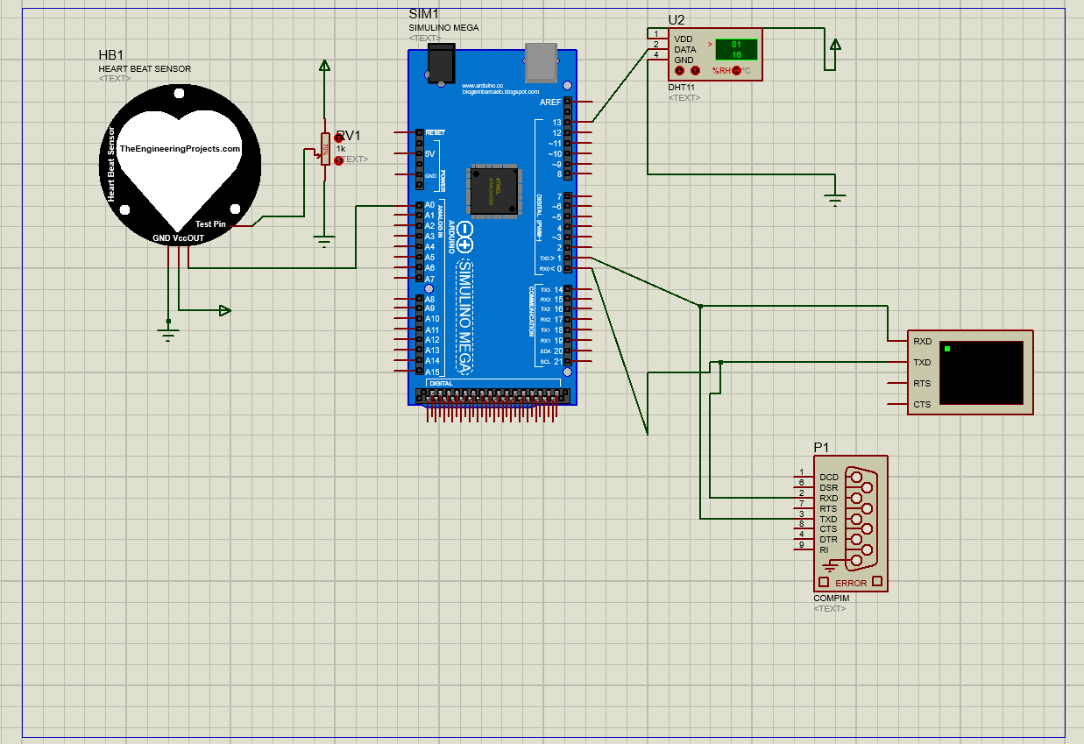

**Methodology:**

Using IoT doctor can continuously monitor the patients on web server and also the patient history will be stored on the web server and doctor can access the information whenever needed from anywhere.

1.DHT sensor and heart beat sensor measure the physiological data from patient and transfer them to the Arduino as electrical signal. Arduino process this physiological data and display patient data on terminal window.

2. we use python language for display the patient physiological data on cloud.

So we are using ThingSpeak. Also we are reading data from ThingSpeak.

Component used:

Arduino Mega:

The Arduino Mega 2560 is a microcontroller board based on the AT mega 2560.It has 54 digital input/output pins of which 14 can be used as PWM outputs,16analog inputs,4 UARTs,a 16 MHz crystal oscillator, a USB connection, a power jack, an ICSP header, and are set button. It contains everything needed to support the microcontroller. The Mega is compatible with most shields designed for the Arduino Duemilanove or Diecimila.

Arduino is interfacing with various modules

* Heart beat sensor
* DHT sensor
* Virtual terminals
* Port.

**Heart beat sensor:**

Electrocardiograph is one of the most ubiquitous machines in the hospitals today. It keeps doctors and nurses updated on important status of patients. ECG collects and interprets electrical signals produced by the heart over time. Capturing these signals is done via electrodes.

A heart beat sensor shall be used to replace the ECG machine. My sensor shall use optical method to sense blood flow in the veins and convert that to heart beat.

Optical method uses the fact that blood vessels in any patch of skin such as fingertips furnished with a good blood supply, alternately expand and contract in time with the heartbeat. A LED and a photo resistor are used to sense this variation in skin contrast. This method uses both transmittance and reflectance principles. It is precise, cheap and non-invasive method due to lack of attachment on the body.

**DHT11 sensor:**

The DHT11 Sensor is placed near the nostril. DHT11 sensor consists of a capacitive humidity sensing element and a thermistor for sensing temperature. Humidity is the water content present in the respired air. The sensor senses the difference in humidity between the inhaled and the exhaled air. This difference is counted for the number of breaths per minute(bpm) which is the respiration rate.

For measuring temperature this sensor uses a Negative Temperature coefficient thermistor, which causes a decrease in its resistance value with increase in temperature. To get larger resistance value even for the smallest change in temperature, this sensor is usually made up of semiconductor ceramics or polymers.

**Virtual terminal:**

Using IoT doctor can continuously monitor the patient's on web server and also the patient history will be stored on the web server and doctor can access the information whenever needed from anywhere.

**VSPE:**

Virtual Serial Port Emulator is a software application that replicates physical COM ports. The virtual serial ports that are created are fully compatible with operating systems and applications and are treated in the same way as a real port.

**Result:**



Fig(1): Main Circuit

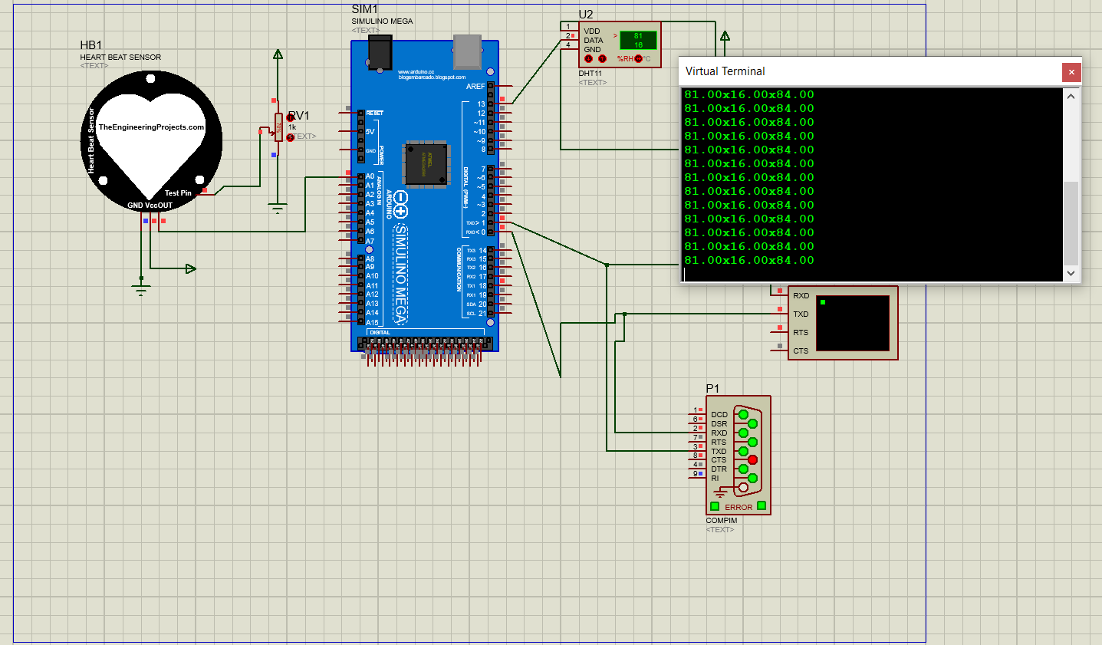

**Fig(2):Simulation on proteus**

Simulation On Proteus: Here we can observe the humidity, temperature and pulse rate on virtual terminal. On virtual terminal the readings are looking like (81.00x16.00x84.00), it means there serially first one 81.00= Humidity; 16.00=Temperature; 84.00=Pulse rate.

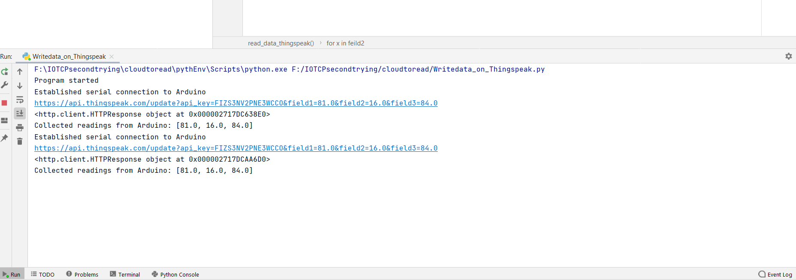

**Fig(3): Reading the data from virtual terminal**

Here this is reading the data from the virtual terminal as shown above in the proteus simulation . And it reading the data by serial communication .For serial communication here we are used the VSPE(Virtual Serial Port Emulator) as mentioned above.

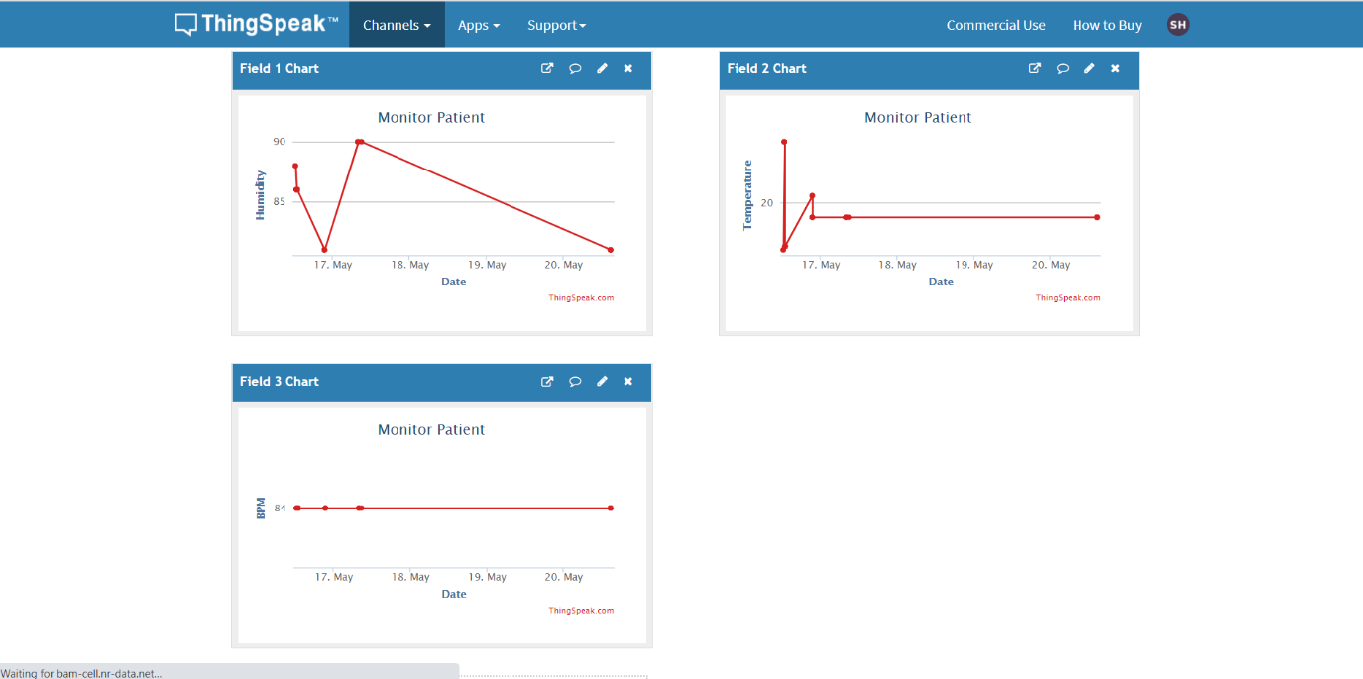

**Fig(4): Data On Thingspeak (Humidity, Temperature and Pulse rate)**

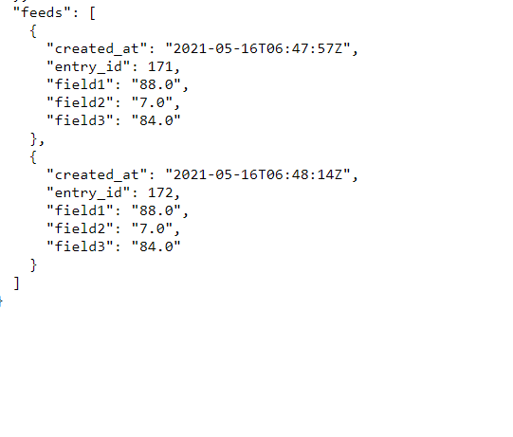

**Fig(5): Data read from Thingspeak**

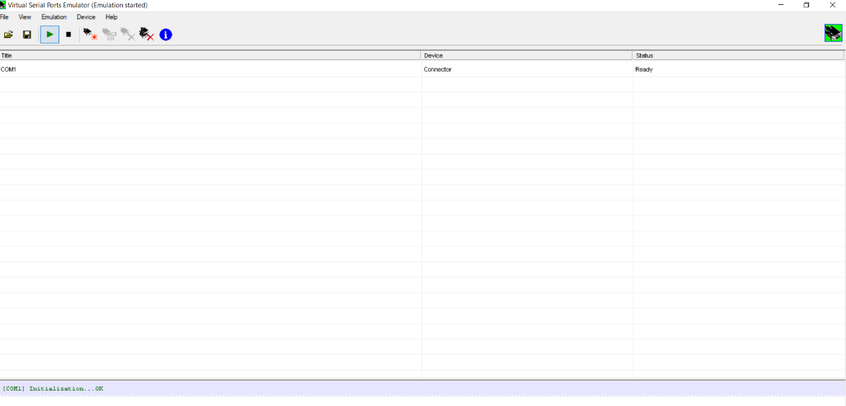

**Fig(6):VSPE(Virtual Serial Port Emulator) setup**

**Conclusion:**

The system introduced smart healthcare to monitor the basic important signs of patients like heart rate, body temperature, and some measures of hospital room’s condition such as room humidity. The rate of success between the observed data and actual data is approximately greater than 95% for all cases of the developed healthcare system. Authentic medical staff can view and track the data in real-time even though the patients perform the tests outside of the hospital.

The system can also benefit nurses and doctors in situations of epidemics or crises as raw medical data can be analysed in a short time. The developed prototype is very simple to design and use.

The system is very useful in the case of infectious disease like a novel coronavirus (COVID-19) treatment. The developed system will improve the current healthcare system that may protect lots of lives from death.

Although the system looks somewhat bulky, it will be a tiny device by proper manufacturing in the near future. The video feature can be added for face to face consultation between the doctors and patients. Some more measures which are very significant to determine a patient’s condition like the level of diabetes, respiration monitoring, etc. can be addressed as future work.

Reference:

1. [IoT Based Patient Monitoring System using ESP8266 and Arduino (circuitdigest.com)](https://circuitdigest.com/microcontroller-projects/iot-based-patient-monitoring-system-using-esp8266-and-arduino)
2. <https://www.researchgate.net/publication/283551827_Low_cost_heart_rate_monitoring_using_fingertips>
3. Cloud based Intelligent Healthcare Monitoring System Mr.Khyamling A. Parane, Mr.Naveenkumar C.Patil, Mr.Shivananda R. Poojara, Mr.Tejaskumar S. Kamble Dept. a/eSE, Rajarambapu Institute a/Technology, Sakharale. Dist: Sangli-415 414 Maharashtra.
4. Low Cost Heart Rate Monitoring Using Fingertips Naman Jain School of computing science and engineering, VIT University, Vellore 632014, Tamil Nadu, India, naman.jain2011@vit.ac.in Priya. G Assistant Professor, SCSE VIT University, Vellore 632014 Tamil Nadu, India, gpriya@vit.ac.in